**BRIDGE BATCH TEST**

Kunal Bandooni

[kunal.bandooni@wissen.com](mailto:kunal.bandooni@wissen.com)

**QUESTION:**

For Student: Perform the CRUD operations on the given domain. Also add functionality to provide login and register the user. You need to have User table, once the user registers, this information should go to User Table. When the user provides a Username and Password for Login, the system should provide as Valid user or Invalid user.

1. Controller - register, login

2. Pojo - extra

3. Repository. - extra

4. Application.properties

**OUTPUT AFTER THE CODE**

**CODE:**

CONTROLLER

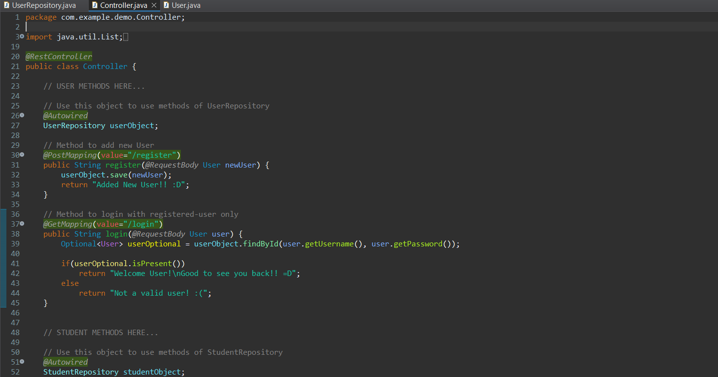

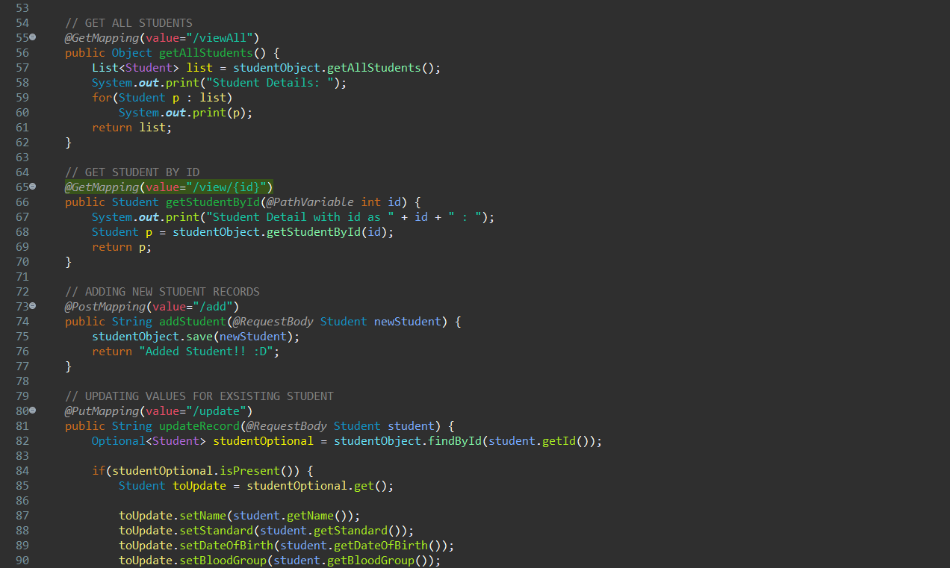

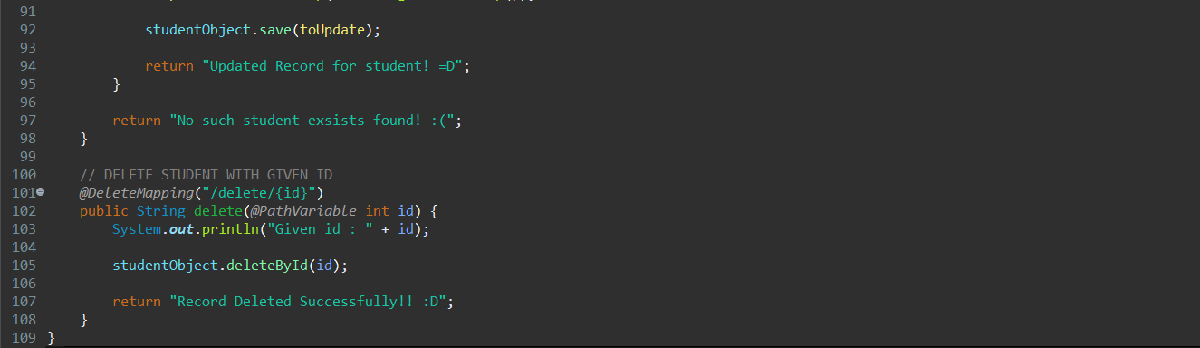

POJO

USER

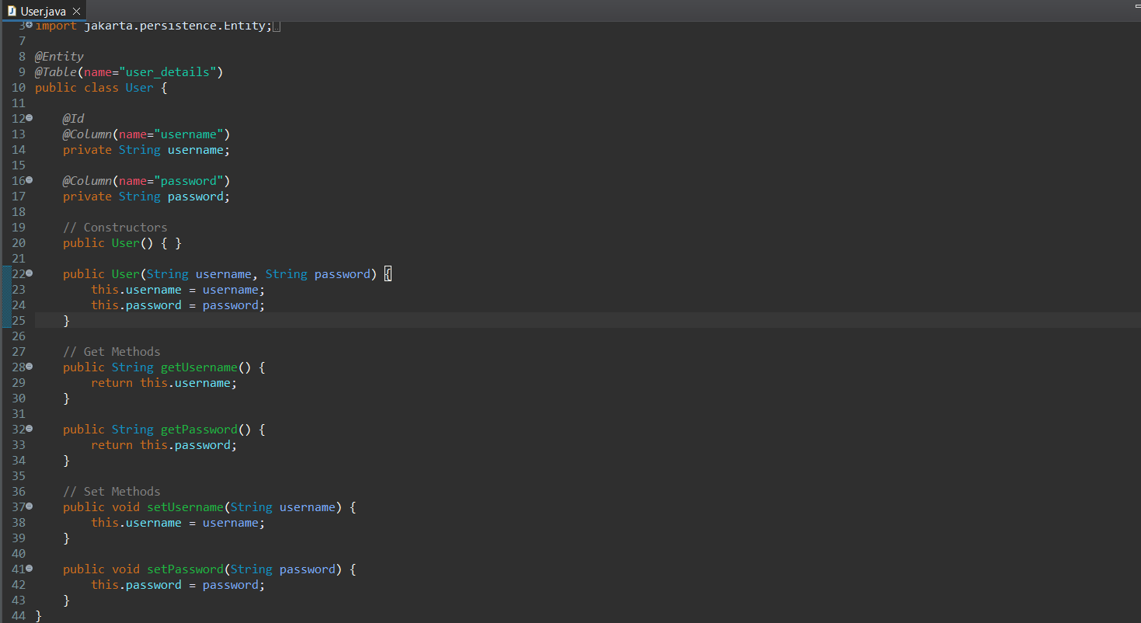

STUDENT

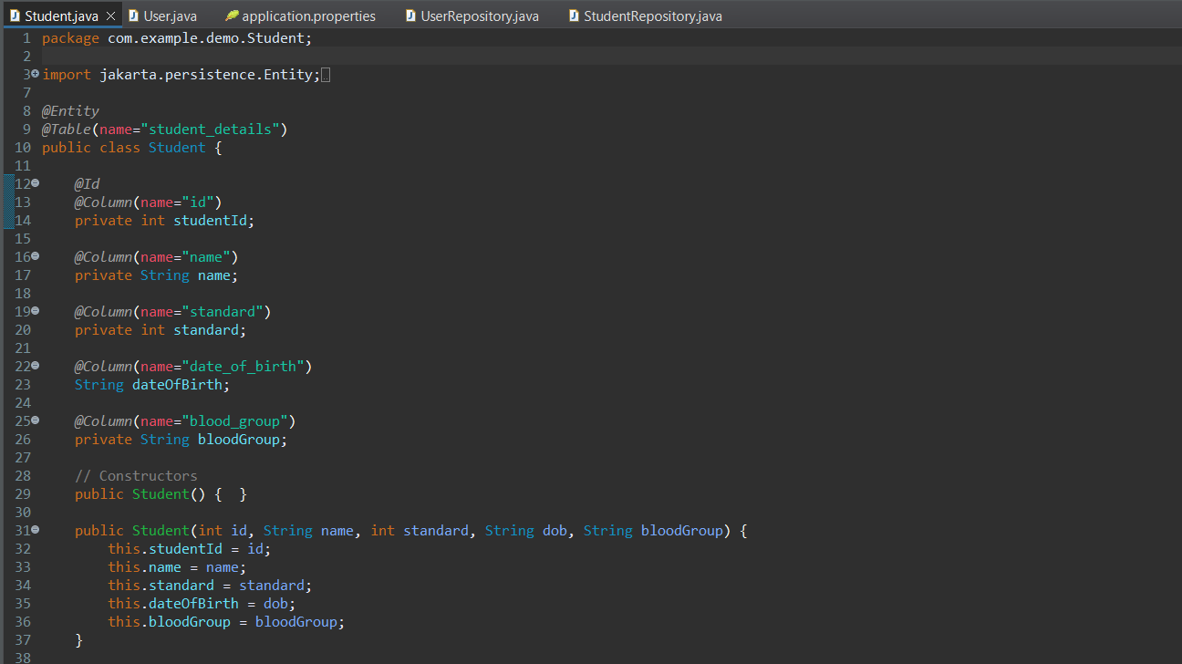

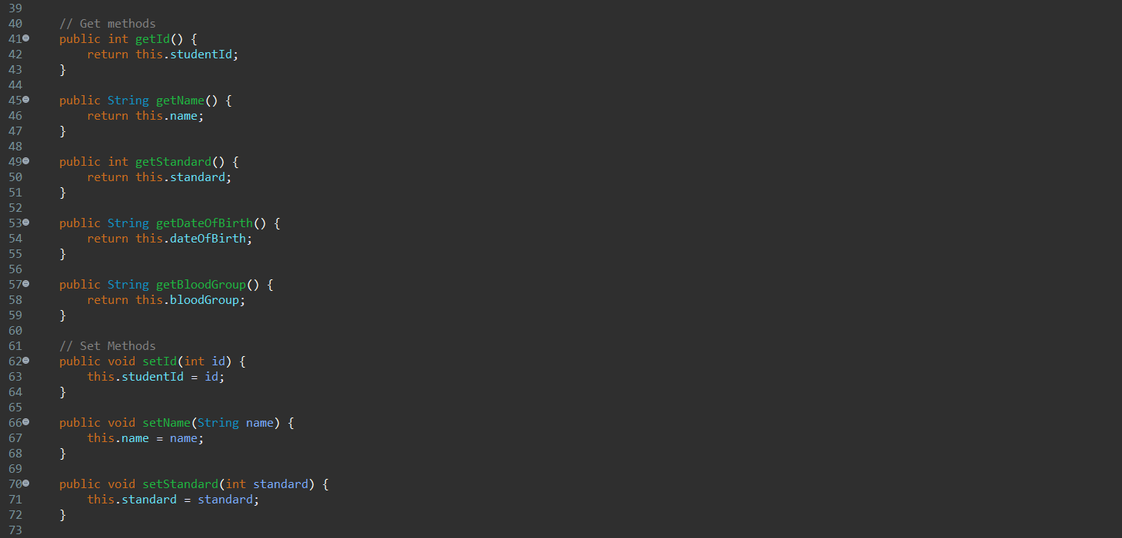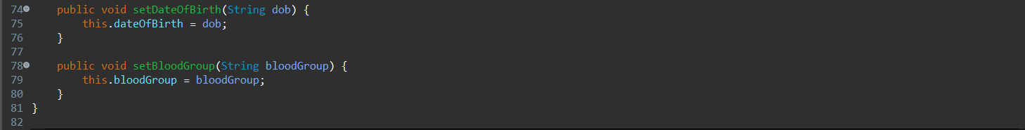



REPOSITORIES

USER REPOSITORY

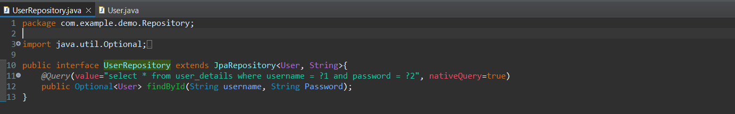

STUDENT REPOSITORY

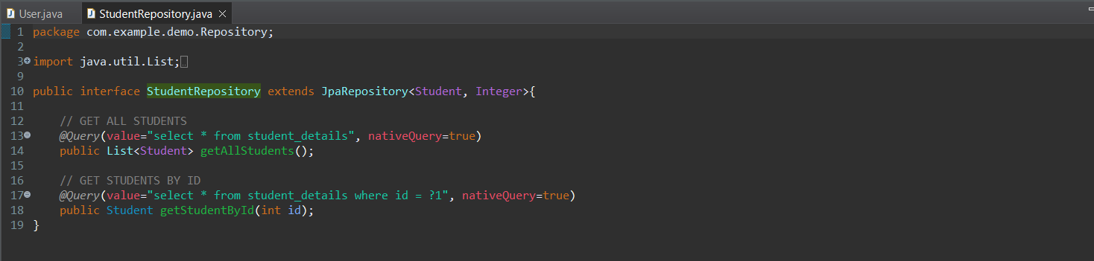

APPLICATION.PROPERTIES

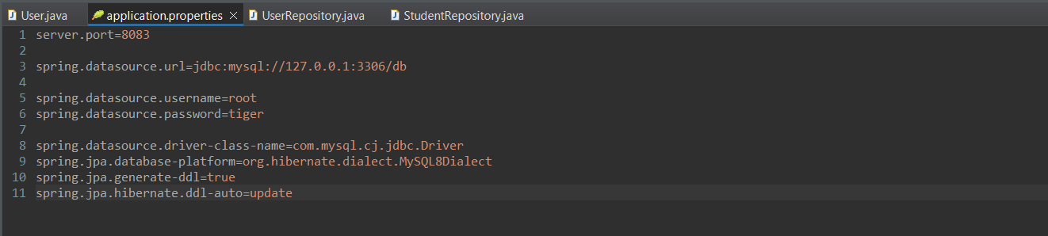

**OUTPUT:**

**USER**

**REGISTER**

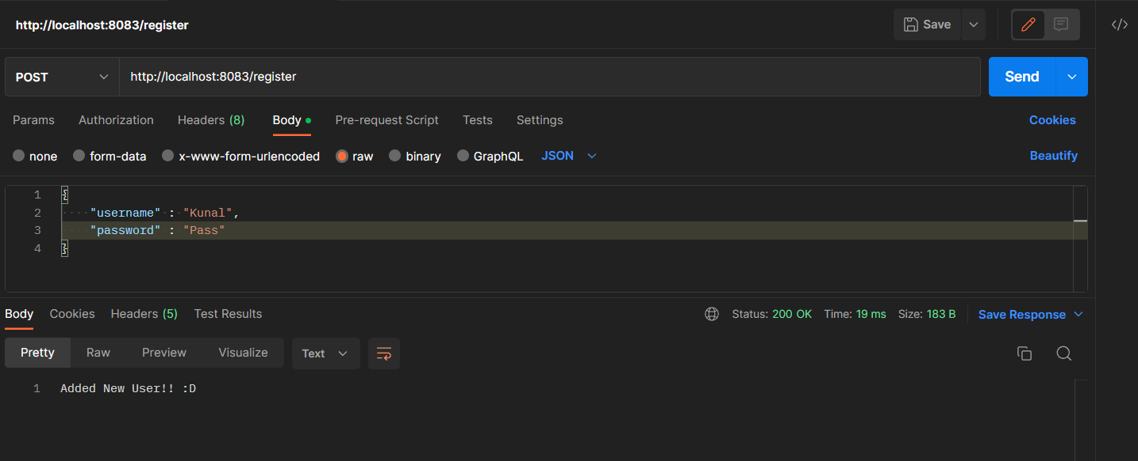

**LOGIN**

VALID

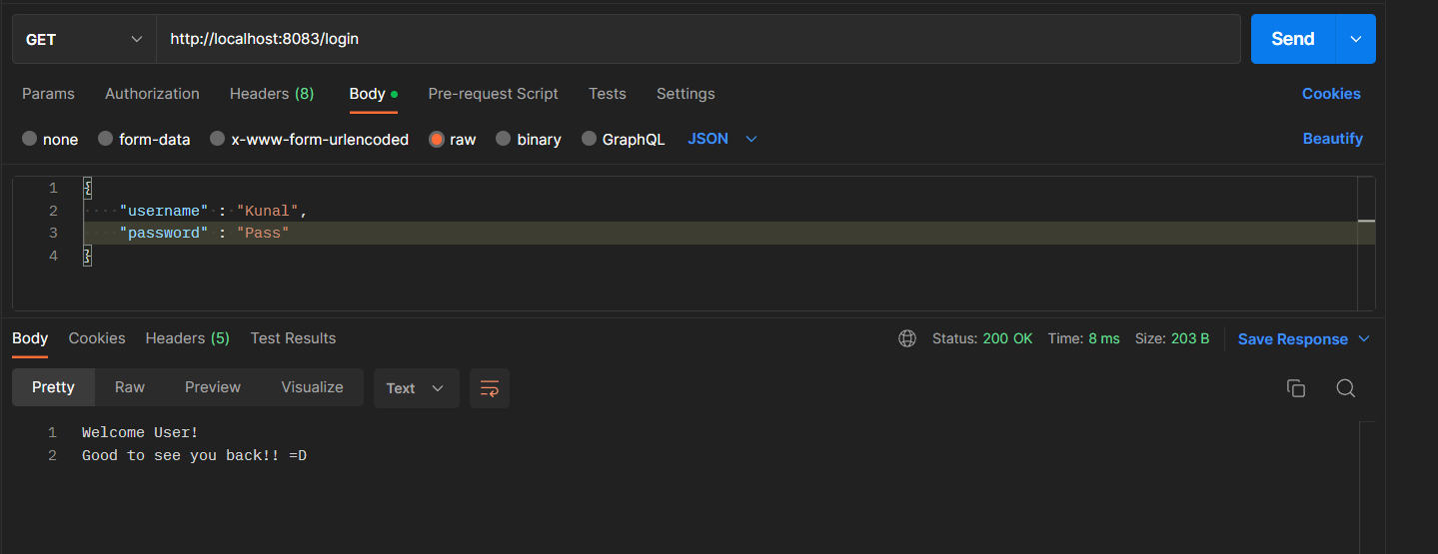

INVALID

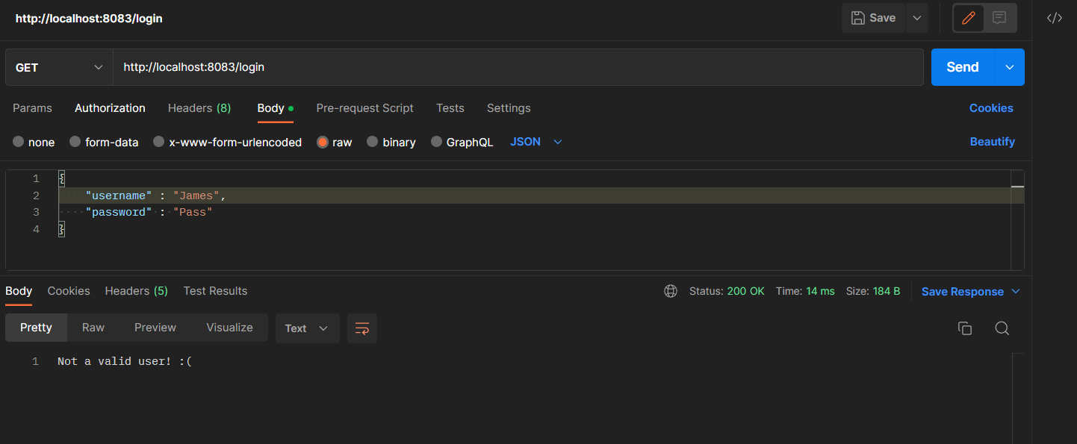

**STUDENT**

POST

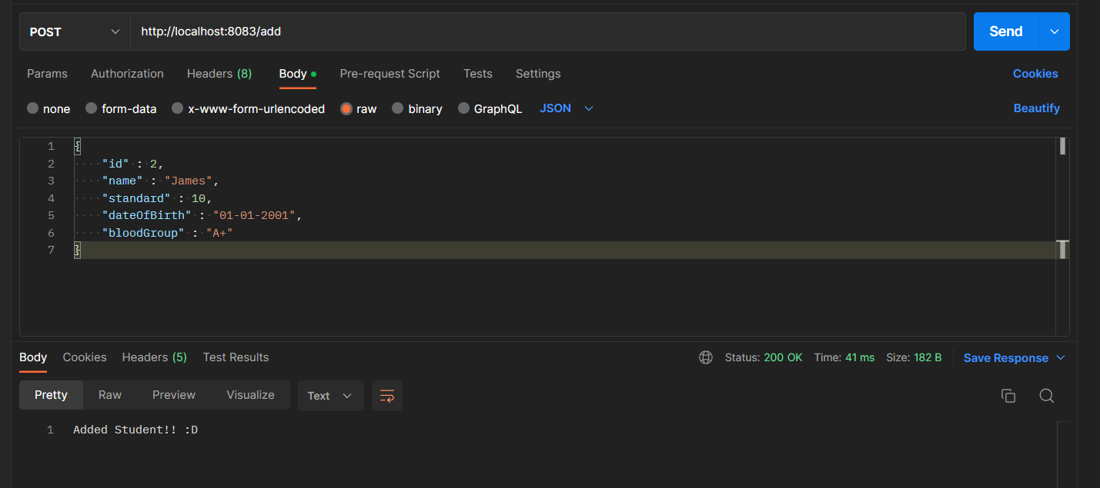

GET

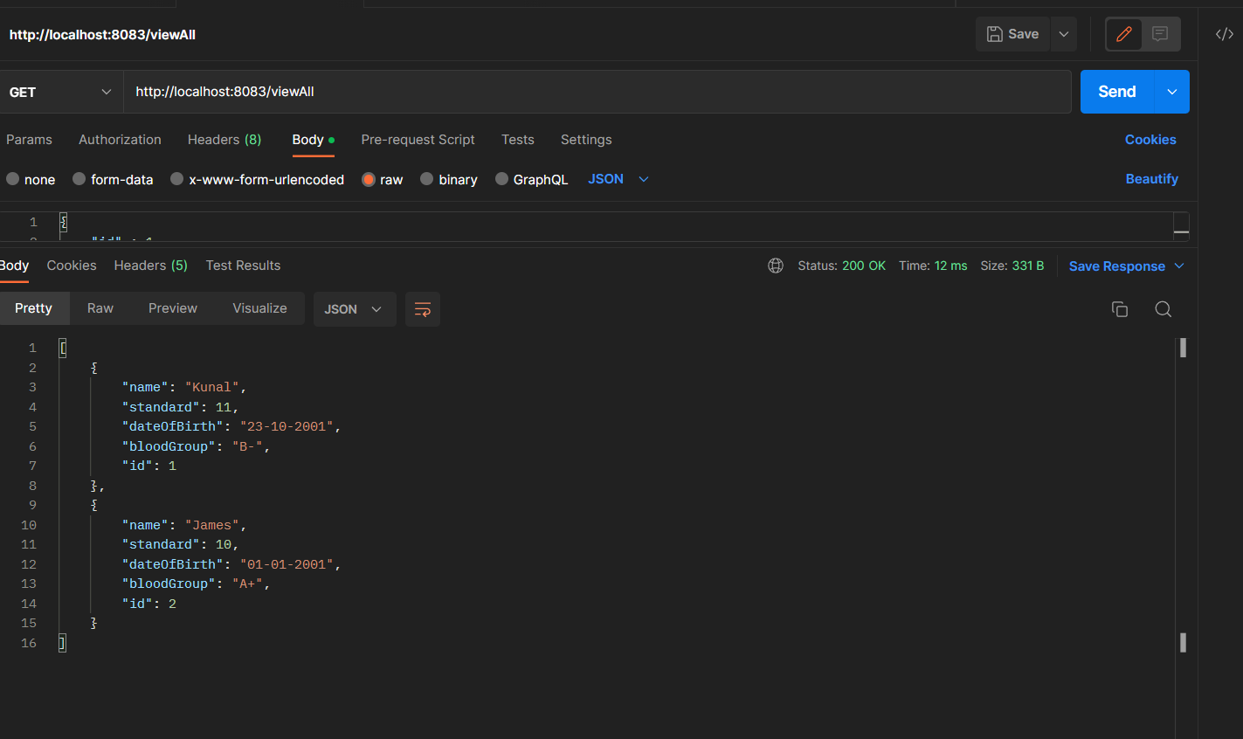

GET BY ID

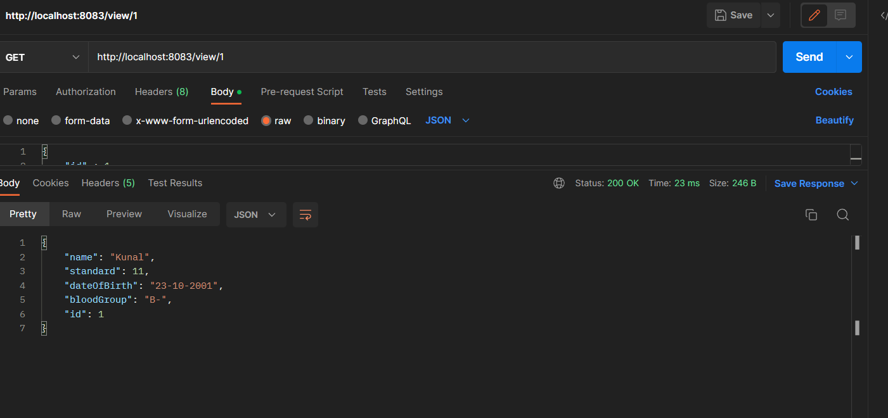

PUT

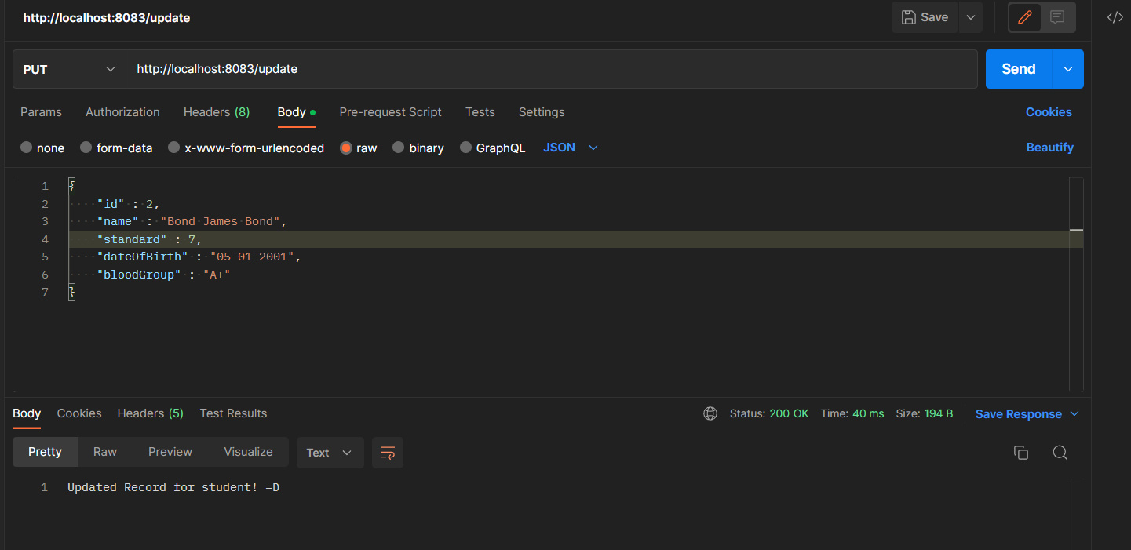

DELETE

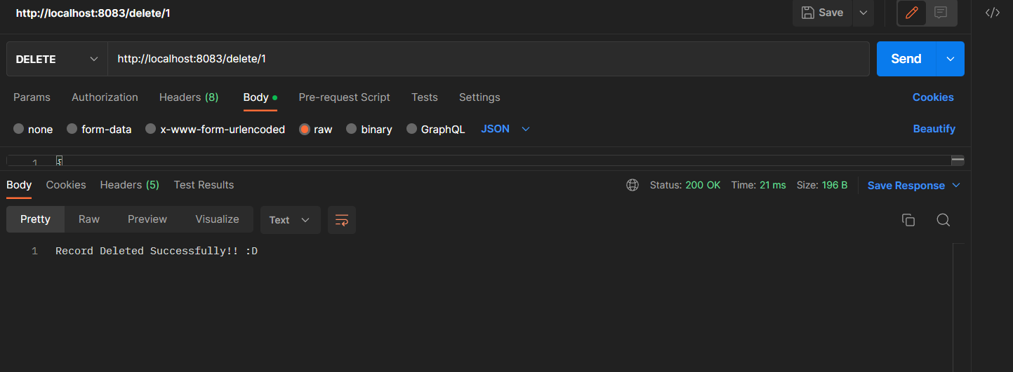

OUTPUT AFTER DELETE:

